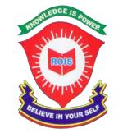 ROYAL OAK INTERNATIONAL SCHOOL
SR. SEC. CBSE AFFILIATED
HOLIDAY HOME WORK (SESSION 2019-20)
Class – II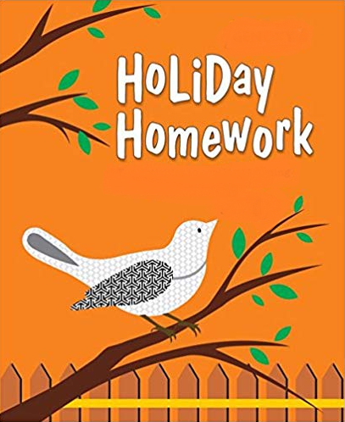

Please note the following:
- HHW of 5 marks will be added as a subject enrichment activity marks in Term I, hence submission of work post summer vacation is compulsory for all the students.
- Schedule for the Submission of HHW for all classes is as follows:
English : 3/07/2019
Hindi : 4/07/2019
Math : 5/07/2019
Evs : 8/07/2019
- Submission dates for Computer, G.K., Art & Craft will be in the 2nd week of July.

Wishing you all a very fruitful and enjoyable vacations. HAPPY HOLIDAY!

FOR THE PARENTS

Summer Vacations are here. A few vital suggestions are listed below to make the vacations more exciting and fruitful than ever before:
- Keep at least half an hour a day for sharing experiences with your child.
- Encourage your child to speak in English. Fix one hour in a day when you communicate with your child only in English.
- Tell your child different stories regularly and encourage him/her to describe what he/she would do in a similar situation. Here are few suggested titles which you can read with your child.
a. Lacey-the little mermaid fairy d. Giraffe can’t dance
b. I like myself (Story book) e. Dolphins at the day break
c. Panchatantra stories
- Let your child colour, draw, paint, Play, Dance etc.
- Restrict his/her television watching, confining it to interesting children’s program, cartoon films, discovery channel etc.
- To improve the formation of letter, make your child write a page every day.
- Develop self help skills: Let your child dress and feed on his/her own.
- Make him/her understand the importance of cleaning his/her room and putting away toys and belongings after use.
- Take your child out for picnics and to other places of his/her interest. Ask him/her to make a note of all the places he/she visits and things he/she sees so that he/she is able to discuss his/her experience in class after vacations.
Have a nice time!
PRINCIPAL

ENGLISH:
- Learn and write a poem you like the most and draw or paste the related picture on A4 sheet.
- Make a ‘Word Tree’ with the “sh” words on A4 sheet.
- Read any 5 stories from your story book “A Treasure of Tales”which you like.
- Do reading practice of ch-1 and ch-4(Book – Wow ) for the Reading Skill test on 5th July.
- Revise the whole syllabus done in the class thoroughly during vacation and take plenty of liquid diet.

HINDI:
- ikB~; & iqLrd ds ikB 1 ] 2] 3] ;kn djks A
- A- 4 lkbt “khV ij ik¡p yksxksa ds fp= fpidkvks tks gekjh lgk;rk djrs gS vkSj muds uke Hkh fy[kksA
- vk¡[k ] dey ] unh ] pk¡n ] /kjrh ] i{kh vkfn ds jax & fcjaxsa fp= ,d= djks ] bUgs pkVZ & isij ij fpidkvksA fp=ksa ds uhps muds nks & nks Ik;kZ;okph “kCn fy[kksA
- A- 3 lkbt “khV ij ,d isM+ dk fp= cukvks vkSj mls gjs vkSj Hkwjs jax ds dkxtksa ds VqdM+ksa ls isM+ dks ltkb,A
- ,d vyx dkWih esa 10 ist lqys[k fy[kksA

MATH:
1.PROJECT: Make 3-D shapes –sphere , cube , cuboid . Using those shapes prepare a model of Robot.
2. Prepare a beautiful chart showing ordinal numbers.(1 to 26)
3. Prepare a separate notebook and
a) Write tables from 2 -10
b) Write counting from 101-1000
c) Prepare a clock using Roman Numerals.
d)Complete the given worksheet.

EVS:
1. Draw and colour a poster on “ save trees” or “save water”. Also write a catchy slogan on it. Do it on A3 size sheet.
2. Make a clay modal of 5 sense organ on card board.
3.Learn ch-1,2 and 3 and do the given work sheet.

COMPUTER:
- Revise PA1 syllabus.
- Draw different tools of paint window in computer notebook and name them with their uses.
- Draw parts of computer according to your Roll No on A3 sheet and write three lines about them.
  - Roll No. 1-8 Monitor and CPU
  - Roll No. 9-16 Mouse and keyboard.
  - Roll No. 17 onwards Speaker and Microphone
- Do the given worksheet.

G.K.:
1. (a) Paste the pictures of any six Monuments of the World and write their names and places where
they are located. (on A3 size sheet) (Roll No. 1 to 15)
(b) Draw or paste the pictures of any ten things that we get from plants and label them.
(on A3 size sheet) ( Roll No. 16 onwards)
2. Revise P. A. I Syllabus.

ART & CRAFT:
1. Five animal face pom-pom
2. Engine with string (Ref. page no 38 in Art & craft)

